

**BGP Implementation Documentation**

Ryan Chen

9/13/2023

**Purpose:**

This lab was primarily used in order to learn basic BGP configuration in conjunction with various routing protocols such as EIGRP, OSPF, and RIP. To do this, we needed to configure both IPv4 and IPv6 versions of BGP. Furthermore, this lab also gave us a refresher on previously learned routing protocols, such as RIP and EIGRP.

**Background Information:**

BGP is an industry standard protocol used for connecting various different company networks, which may or may not be running on different routing protocols and employ different configuration standards. It is highly important as it allows networks from all around the world to connect to each other, which is the basis for the Internet. Each of these networks that originate from different organizations/companies is referred to as an Autonomous System (AS). BGP allows all these different ASes to share routing information and create a single, interconnected route.

Often times, each AS uses different routing protocols. Industry standards include OSPF, EIGRP, and RIP, however RIP has largely been replaced by more efficient protocols. While these protocols would normally be unable to share routing tables, BGP is a centralized protocol that allows each AS to share and receive routes.

The BGP protocol has a wide variety of configurable attributes that allow it to be highly flexible for both large scale enterprise and also small-scale company level use. The three attributes we focused on are path weight, atomic aggregation, and normal aggregation. In combination, these attributes allowed us to manipulate BGP routes to demonstrate the capabilities of configuration with BGP.

The weight BGP attribute allows us to manually assign a priority to routes distributed by BGP. The number spans from 0 to 65535 and is set on a per route basis. Weight is a local preference, meaning that it isn’t distributed to other routers. Each router holds its own locally set route preferences that influence preferred path. Routes with local prefixes (which originate from the router itself) receive a weight of 32768, and the default weight is 0. Changing weight is typically used on a router-by-router basis to prefer a specific route when two routes are present from different AS’es for the same prefix. This allows a network administrator to pick the faster/more desirable path to optimize BGP.

The other two attributes involve subnet aggregation. BGP aggregation combines routes that advertise prefixes which fall under a common subnet/address block. This is used to reduce the number of routes that BGP has to distribute and store, in turn maximizing efficiency and speed. We primarily utilized two types of aggregation: normal and atomic. Normal aggregation simplifies routes that have similar network subnets. For instance, a 192.168.0.0/25 and a 192.168.0.127/25 will be aggregated into the 192.168.0.0/24 network to reduce the number of routes and packets sent. This reduces network congestion and router resource utilization, which increases BGP speed. On the other hand, atomic aggregation causes all packets with a destination to a previously aggregated network to be sent to the router that initially performed aggregation. If atomic aggregation is configured, it will point towards a router that performs normal aggregation. Thus, any packets that have a destination of an aggregated route will be forwarded to that router that has normal aggregation.

**Lab Summary:**

In this lab, our objective was to configure a working BGP network that allows multiple different routing protocols to distribute and receive routes. To do so, we first designed a plausible network topology in Packet Tracer. To simplify future configuration, we decided to simulate the three different types of routing protocols using loopback interfaces. Furthermore, each loopback interface was assigned to a larger subnet block, and these subnet blocks would then be distributed across BGP. This allowed for easier troubleshooting, as the subnet blocks would be clearly identifiable in the routing table.

After completing our topology, we started by configuring each routing protocol locally to each router. Upon confirming that all three were working as intended, we moved onto the inter-protocol BGP area. BGP configuration was quite simple as our topology allowed us to easily add neighbors and distribute routes. After setting up BGP, we were able to identify that it was performing as expected by checking each routing table. Each router was populated with neighboring BGP routes, and we were able to confirm that pings across protocols worked using the built-in ping feature on the router.

Afterwards, we chose three attributes and set them up. The weight attribute did not actually influence route selection, as our topology only had one route that could be used, however we were able to configure and confirm that it was working. To demonstrate normal and atomic subnet aggregation, we split our EIGRP and RIP networks into two /25 subnets and configured aggregation to combine them back into a /24. We were able to verify this by viewing routing tables and checking for the aggregation flag.

**Lab Commands:**

*router bgp [PROCESS-ID]*

-Initializes the BGP process

*bgp router-id [ROUTER-ID]*

-Sets BGP router-id for neighbors

*neighbor [IPv4/IPv6-ADDRESS] remote-as [AS-NUMBER] weight [WEIGHT-VALUE]*

-Adds a BGP neighbor, with optional BGP weight value attribute

*neighbor [IP-ADDRESS] activate*

-Establishes BGP adjacency with neighbor

*redistribute [ROUTING-PROTOCOL] [AS-NUMBER]*

-Redistribute routing protocol routes into BGP (OSPF, RIP, EIGRP)

*address-family [IPv4/IPv6]*

-Specifies IPv4 or IPv6 configurations for BGP

*network [ADDRESS]*

-Adds a network under IPv4 or IPv6

*aggregate-address [ADDRESS] [SUBNET-MASK] summary-only*

-Configures normal subnet aggregation

*aggregate-address [ADDRESS] [SUBNET-MASK] as-set summary-only*

-Configures atomic subnet aggregation

*show ip bgp*

-Shows all BGP routes

*clear ip bgp \**

-Reload the BGP process and delete all stored routes, reestablish neighbors

**Network Diagram and IP Table:**

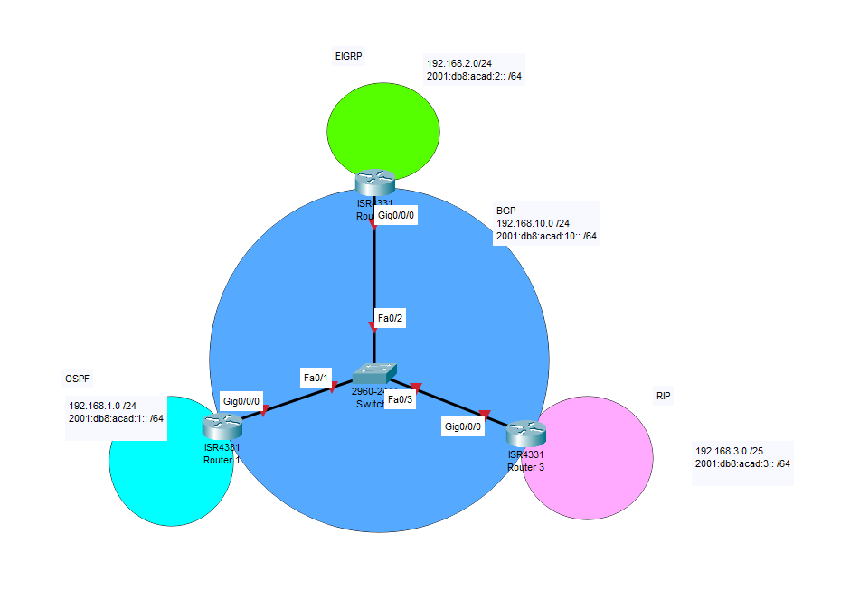

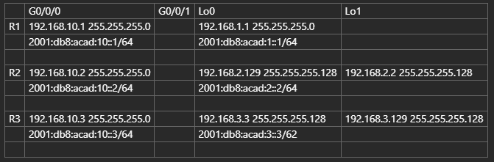

**Configurations:**

**R1**

hostname R1

boot-start-marker

boot-end-marker

vrf definition Mgmt-intf

address-family ipv4

exit-address-family

address-family ipv6

exit-address-family

no aaa new-model

ipv6 unicast-routing

subscriber templating

multilink bundle-name authenticated

license udi pid ISR4321/K9 sn FDO21491LXV

license accept end user agreement

license boot level securityk9

spanning-tree extend system-id

redundancy

mode none

vlan internal allocation policy ascending

interface Loopback0

ip address 192.168.1.1 255.255.255.0

ipv6 address 2001:DB8:ACAD:1::1/64

ipv6 ospf 1 area 0

interface GigabitEthernet0/0/0

ip address 192.168.10.1 255.255.255.0

negotiation auto

ipv6 address 2001:DB8:ACAD:10::1/64

interface GigabitEthernet0/0/1

no ip address

shutdown

negotiation auto

interface Serial0/1/0

no ip address

shutdown

interface Serial0/1/1

no ip address

shutdown

interface GigabitEthernet0

vrf forwarding Mgmt-intf

no ip address

shutdown

negotiation auto

interface Vlan1

no ip address

shutdown

router ospf 1

router-id 1.1.1.1

network 192.168.1.0 0.0.0.255 area 0

router bgp 1

bgp router-id 1.1.1.1

bgp log-neighbor-changes

neighbor 2001:DB8:ACAD:10::2 remote-as 2

neighbor 2001:DB8:ACAD:10::3 remote-as 3

neighbor 192.168.10.2 remote-as 2

neighbor 192.168.10.3 remote-as 3

address-family ipv4

network 192.168.1.0

network 192.168.10.0

redistribute ospf 1

no neighbor 2001:DB8:ACAD:10::2 activate

no neighbor 2001:DB8:ACAD:10::3 activate

neighbor 192.168.10.2 activate

neighbor 192.168.10.2 weight 1337

neighbor 192.168.10.3 activate

exit-address-family

address-family ipv6

redistribute ospf 1

network 2001:DB8:ACAD:1::/64

network 2001:DB8:ACAD:10::/64

neighbor 2001:DB8:ACAD:10::2 activate

neighbor 2001:DB8:ACAD:10::3 activate

exit-address-family

ip forward-protocol nd

no ip http server

no ip http secure-server

ip tftp source-interface GigabitEthernet0

ipv6 router ospf 1

router-id 1.1.1.1

control-plane

line con 0

stopbits 1

line aux 0

stopbits 1

line vty 0 4

login

Codes: L - local, C - connected, S - static, R - RIP, M - mobile, B - BGP  
       D - EIGRP, EX - EIGRP external, O - OSPF, IA - OSPF inter area  
       N1 - OSPF NSSA external type 1, N2 - OSPF NSSA external type 2  
       E1 - OSPF external type 1, E2 - OSPF external type 2  
       i - IS-IS, su - IS-IS summary, L1 - IS-IS level-1, L2 - IS-IS level-2  
       ia - IS-IS inter area, * - candidate default, U - per-user static route  
       o - ODR, P - periodic downloaded static route, H - NHRP, l - LISP  
       a - application route  
       + - replicated route, % - next hop override, p - overrides from PfR

Gateway of last resort is not set

      192.168.1.0/24 is variably subnetted, 2 subnets, 2 masks  
C        192.168.1.0/24 is directly connected, Loopback0  
L        192.168.1.1/32 is directly connected, Loopback0  
B     192.168.2.0/24 [20/0] via 192.168.10.2, 00:32:12  
B     192.168.3.0/24 [20/0] via 192.168.10.3, 00:31:59  
      192.168.10.0/24 is variably subnetted, 2 subnets, 2 masks  
C        192.168.10.0/24 is directly connected, GigabitEthernet0/0/0  
L        192.168.10.1/32 is directly connected, GigabitEthernet0/0/0 **R2**

hostname R2

boot-start-marker

boot-end-marker

vrf definition Mgmt-intf

address-family ipv4

exit-address-family

address-family ipv6

exit-address-family

no aaa new-model

ipv6 unicast-routing

subscriber templating

multilink bundle-name authenticated

license udi pid ISR4321/K9 sn FDO214420QQ

license accept end user agreement

license boot level securityk9

spanning-tree extend system-id

redundancy

mode none

vlan internal allocation policy ascending

interface Loopback0

ip address 192.168.2.129 255.255.255.128

ipv6 address 2001:DB8:ACAD:2::2/64

ipv6 eigrp 2

interface Loopback1

ip address 192.168.2.2 255.255.255.128

interface GigabitEthernet0/0/0

ip address 192.168.10.2 255.255.255.0

negotiation auto

ipv6 address 2001:DB8:ACAD:10::2/64

ipv6 eigrp 2

interface GigabitEthernet0/0/1

no ip address

shutdown

negotiation auto

interface Serial0/1/0

no ip address

shutdown

interface Serial0/1/1

no ip address

shutdown

interface GigabitEthernet0

vrf forwarding Mgmt-intf

no ip address

shutdown

negotiation auto

interface Vlan1

no ip address

shutdown

router eigrp 2

network 192.168.2.0 0.0.0.127

network 192.168.2.128 0.0.0.127

eigrp router-id 2.2.2.2

router bgp 2

bgp router-id 2.2.2.2

bgp log-neighbor-changes

neighbor 2001:DB8:ACAD:10::1 remote-as 1

neighbor 2001:DB8:ACAD:10::3 remote-as 3

neighbor 192.168.10.1 remote-as 1

neighbor 192.168.10.3 remote-as 3

address-family ipv4

network 192.168.2.0 mask 255.255.255.128

network 192.168.2.128 mask 255.255.255.128

network 192.168.10.0

aggregate-address 192.168.2.0 255.255.255.0 summary-only

redistribute eigrp 2

no neighbor 2001:DB8:ACAD:10::1 activate

no neighbor 2001:DB8:ACAD:10::3 activate

neighbor 192.168.10.1 activate

neighbor 192.168.10.3 activate

exit-address-family

address-family ipv6

redistribute eigrp 2

network 2001:DB8:ACAD:2::/64

network 2001:DB8:ACAD:10::/64

neighbor 2001:DB8:ACAD:10::1 activate

neighbor 2001:DB8:ACAD:10::3 activate

exit-address-family

ip forward-protocol nd

no ip http server

no ip http secure-server

ip tftp source-interface GigabitEthernet0

ipv6 router eigrp 1

eigrp router-id 2.2.2.2

control-plane

line con 0

stopbits 1

line aux 0

stopbits 1

line vty 0 4

login

Codes: L - local, C - connected, S - static, R - RIP, M - mobile, B - BGP  
       D - EIGRP, EX - EIGRP external, O - OSPF, IA - OSPF inter area  
       N1 - OSPF NSSA external type 1, N2 - OSPF NSSA external type 2  
       E1 - OSPF external type 1, E2 - OSPF external type 2  
       i - IS-IS, su - IS-IS summary, L1 - IS-IS level-1, L2 - IS-IS level-2  
       ia - IS-IS inter area, * - candidate default, U - per-user static route  
       o - ODR, P - periodic downloaded static route, H - NHRP, l - LISP  
       a - application route  
       + - replicated route, % - next hop override, p - overrides from PfR

Gateway of last resort is not set

B     192.168.1.0/24 [20/0] via 192.168.10.1, 00:34:18  
      192.168.2.0/24 is variably subnetted, 5 subnets, 3 masks  
B        192.168.2.0/24 [200/0], 00:34:36, Null0  
C        192.168.2.0/25 is directly connected, Loopback1  
L        192.168.2.2/32 is directly connected, Loopback1  
C        192.168.2.128/25 is directly connected, Loopback0  
L        192.168.2.129/32 is directly connected, Loopback0  
B     192.168.3.0/24 [20/0] via 192.168.10.3, 00:34:25  
      192.168.10.0/24 is variably subnetted, 2 subnets, 2 masks  
C        192.168.10.0/24 is directly connected, GigabitEthernet0/0/0  
L        192.168.10.2/32 is directly connected, GigabitEthernet0/0/0

**R3**

hostname R3

boot-start-marker

boot-end-marker

vrf definition Mgmt-intf

address-family ipv4

exit-address-family

address-family ipv6

exit-address-family

no aaa new-model

ipv6 unicast-routing

subscriber templating

vtp domain cisco

vtp mode transparent

multilink bundle-name authenticated

license udi pid ISR4321/K9 sn FDO214420HY

license boot level securityk9

spanning-tree extend system-id

redundancy

mode none

vlan internal allocation policy ascending

vlan 10,20

interface Loopback0

ip address 192.168.3.3 255.255.255.128

ipv6 address 2001:DB8:ACAD:3::3/64

ipv6 rip 1 enable

interface Loopback1

ip address 192.168.3.129 255.255.255.128

interface GigabitEthernet0/0/0

ip address 192.168.10.3 255.255.255.0

negotiation auto

ipv6 address 2001:DB8:ACAD:10::3/64

interface GigabitEthernet0/0/1

no ip address

negotiation auto

interface Serial0/1/0

no ip address

interface Serial0/1/1

no ip address

interface GigabitEthernet0

vrf forwarding Mgmt-intf

no ip address

negotiation auto

interface Vlan1

no ip address

router rip

network 192.168.3.0

router bgp 3

bgp router-id 3.3.3.3

bgp log-neighbor-changes

neighbor 2001:DB8:ACAD:10::1 remote-as 1

neighbor 2001:DB8:ACAD:10::2 remote-as 2

neighbor 192.168.10.1 remote-as 1

neighbor 192.168.10.2 remote-as 2

address-family ipv4

network 192.168.10.0

aggregate-address 192.168.3.0 255.255.255.0 as-set summary-only

redistribute rip

no neighbor 2001:DB8:ACAD:10::1 activate

no neighbor 2001:DB8:ACAD:10::2 activate

neighbor 192.168.10.1 activate

neighbor 192.168.10.2 activate

neighbor 192.168.10.2 weight 1337

exit-address-family

address-family ipv6

redistribute rip 1

network 2001:DB8:ACAD:3::/64

network 2001:DB8:ACAD:10::/64

neighbor 2001:DB8:ACAD:10::1 activate

neighbor 2001:DB8:ACAD:10::2 activate

exit-address-family

ip forward-protocol nd

no ip http server

no ip http secure-server

ipv6 router rip 1

control-plane

line con 0

stopbits 1

line aux 0

stopbits 1

line vty 0 4

login

Codes: L - local, C - connected, S - static, R - RIP, M - mobile, B - BGP  
       D - EIGRP, EX - EIGRP external, O - OSPF, IA - OSPF inter area  
       N1 - OSPF NSSA external type 1, N2 - OSPF NSSA external type 2  
       E1 - OSPF external type 1, E2 - OSPF external type 2  
       i - IS-IS, su - IS-IS summary, L1 - IS-IS level-1, L2 - IS-IS level-2  
       ia - IS-IS inter area, * - candidate default, U - per-user static route  
       o - ODR, P - periodic downloaded static route, H - NHRP, l - LISP  
       a - application route  
       + - replicated route, % - next hop override, p - overrides from PfR

Gateway of last resort is not set

B     192.168.1.0/24 [20/0] via 192.168.10.1, 00:34:58  
B     192.168.2.0/24 [20/0] via 192.168.10.2, 00:35:17  
      192.168.3.0/24 is variably subnetted, 5 subnets, 3 masks  
B        192.168.3.0/24 [200/0], 00:35:17, Null0  
C        192.168.3.0/25 is directly connected, Loopback0  
L        192.168.3.3/32 is directly connected, Loopback0  
C        192.168.3.128/25 is directly connected, Loopback1  
L        192.168.3.129/32 is directly connected, Loopback1  
      192.168.10.0/24 is variably subnetted, 2 subnets, 2 masks  
C        192.168.10.0/24 is directly connected, GigabitEthernet0/0/0  
L        192.168.10.3/32 is directly connected, GigabitEthernet0/0/0

**BGP Attributes:**

**Weight (1337)**

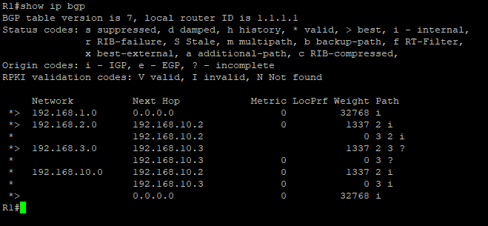

**Atomic and Normal Aggregation (Suppressed / Atomic)**

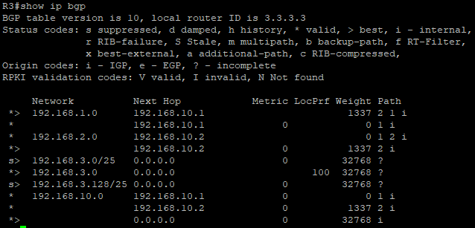

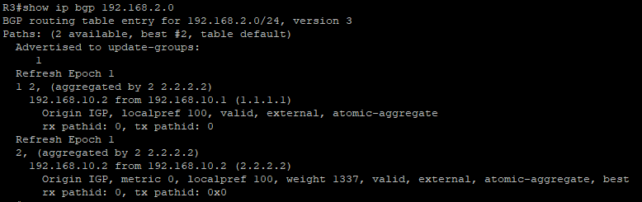

**Pings:**

*Note: Traceroutes are omitted because our network is small and hardly includes any address hops*

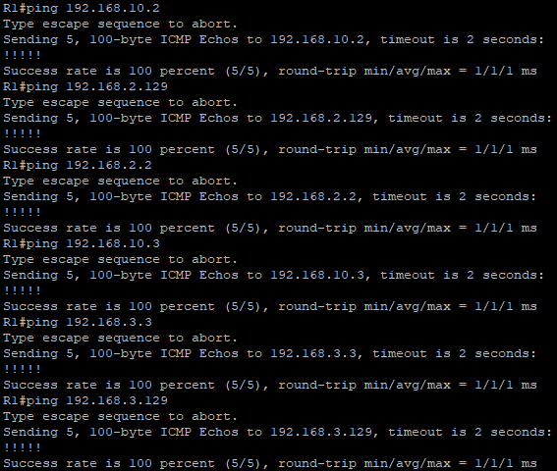

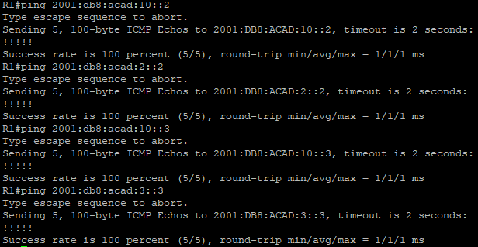 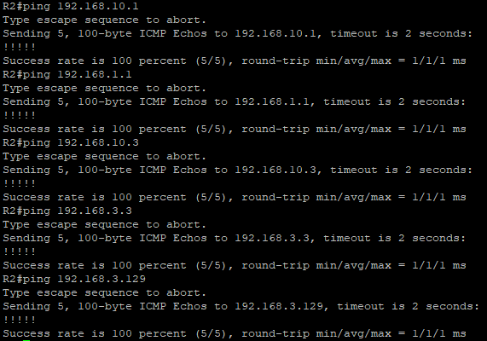 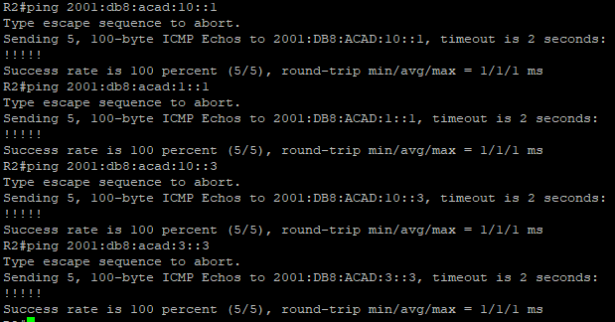 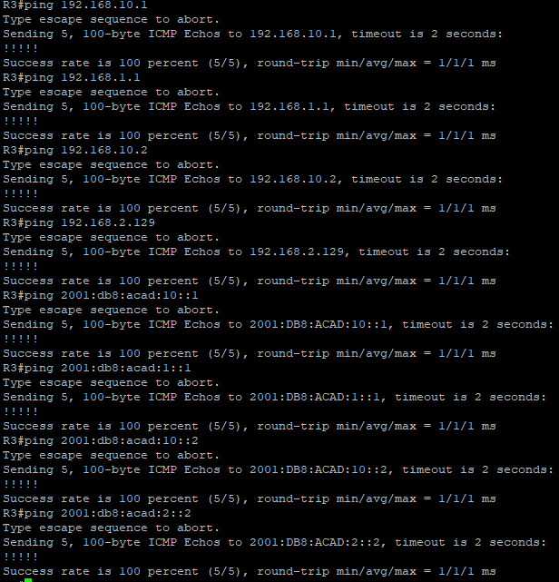

**Problems:**

1. Atomic vs Normal aggregation

When trying to configure this attribute, we had trouble understand the differences between the two types and which commands we needed to use for which. We initially thought as-set was normal aggregation, but later realized that it was atomic and that no as-set was normal. Furthermore, we also did not know how to setup the attribute correctly, which we later figured out that we had to split our Loopback network into two subnets and then aggregate them again.

1. Viewing BGP info

When trying to configure attributes, we struggled to verify whether or not they were functioning correctly, since we didn’t know the basic BGP view commands. Later on, we learned that “show ip bgp” allows us to view weights, and that “show ip bgp [ADDRESS]” allows us to view normal/atomic subnet aggregation.

1. Router-Specific Issues

Some of the routers that we loaded our configs into (on days that we didn’t have access to our normal rack) did not function as we expected. A few of the routers had some different type of command/functionality which affected our configs and rendered them useless. This meant that we were only able to use our configs on the routers that we usually worked with, slowing our progress down quite significantly.

**Conclusion:**

BGP is an industry standard routing protocol that allows different routing protocols such as OSPF, EIGRP, and RIP to communicate and distribute routes amongst themselves. Without BGP, these different protocols would not be able to share routing tables. Furthermore, BGP attributes allow BGP to be highly flexible to adapt to individual needs. Attributes such as subnet aggregation allow for faster operation and lower resource usage, whereas weight allows route selection to be optimized. Overall, knowing BGP configuration is a crucial part of networking, as it is used in much of the modern Internet to provide connectivity.

BGP Signoff Sheet

Ryan Chen, P3-4 Cisco CCNP, Mr. Mason

